Winter Online Classes 2020/20201

Randy Hale

December 10, 2020.
- 2-3 hour workshop class in the morning: Planning & Painting with Negative Shapes in Watercolor.
- Hosts: Bill & Lois Breckon, owners of The Watermill of Posara (Tuscany, Italy). No fee, simply a donation of your choice to register.
- Link: https://www.eventbrite.co.uk/e/watercolours-painting-negative-shapes-with-randy-hale-registration-130394895643

- January 13, 20, 27 & Feb 3 - Four Consecutive Wednesdays
- 3 hour Zoom class in the mornings, 9 am - noon. Topic: Painting Luminous Shadows
- Host: Randy Hale. Register thru CAE website.
- Fee: $125 for members; $140 non-members
- Link for registration & payment: https://evergreenarts.org/event/painting-luminous-shadows-mornings-with-randy-hale/
- 3-hour Zoom class in the afternoons, 1-4 pm. Class Title: Effective Use of Negative Shapes
- Host: Randy Hale. Register thru CAE website.
- Fee: $125 for members; $140 non-members
- Link for registration & payment: https://evergreenarts.org/event/effective-use-of-negative-shapes-in-watercolor-afternoons-with-randy-hale/

Kathleen Lanzoni

Watercolor Experience
Wednesdays, 10 am – 12 pm
January 6 – 27, 2021 Watercolor Class

Online via Zoom
Join in on the fun of watercolor painting
from the comfort of your home
4 sessions & 4 paintings
3 critiques
Sign up today- email KathleenLanzoni@gmail.com
Using the exciting medium of watercolor, learn about painting colorful still life’s, landscapes, animals and more. The focus of the classes will be to enjoy learning watercolor techniques using four different subjects as our models.
Class begins with a discussion and demonstration. Next, you can paint along with the demonstration or you can watch the demonstration and paint on your own schedule. Students may submit finished paintings to be critiqued during the following live class. Artist’s will receive a video recording of the class. Let’s have fun with the magic of watercolors!
4 classes- $95.00

Candace French

Class Title: Exploring Acrylics
Day of the Week: Wednesday
Dates: January 27 and February 3, 10, 17, 24
Times: 10:00AM to Noon MST
Cost: $95.00 before January 13, 2021 $125.00 after January 13, 2021
Registration: http://candacefrench.com/workshop/25951/exploring-acrylics

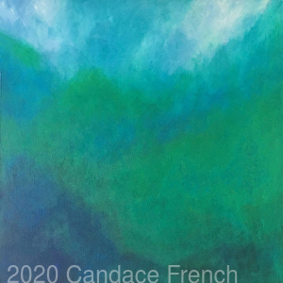

Want to experience painting with acrylics for the first time and don’t know where to start? Or, have you been working in another medium and want to expand into acrylics? If YES, then, this class is for you!

During this live online experience, painters are invited to explore blending brilliant colors, different brushwork techniques, playing with palette knife painting and more. You’ll enjoy "chalk talks", demos and critiques. Composition and The Five Easy Steps to Jumpstart Any Painting and Bring It to Completion will be shared. Bring an image or photo that makes your heart sing! No experience necessary. Experienced artists welcome. Repeat this class and build on what you previously learned.

Join in on the fun of painting with acrylics from the comfort of your home.
This will be a two hour Zoom call. Students will be email the Zoom meeting link 24hrs prior the class.
Five week class.
Ages 18 and above.
Supply list provided upon registration.

I can't wait to see what you create!

Class Title: Exploring Mixed Media
Day of the Week: Wednesday
Dates: April 7, 14, 21, 28
Times: 10:00AM to Noon MST
Cost: $75.00 before March 24, 2021 $95.00 after March 24, 2021
Registration: http://candacefrench.com/workshop/25982/exploring-mixed-media

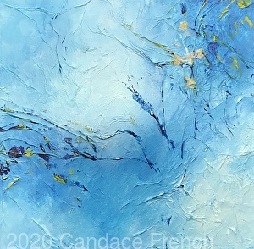

Want to experience painting with Mixed Media for the first time and don’t know where to start? If YES, then, this class is for you!

Explore the amazing world of Mixed Media! Experience texture, foils, charcoal and mediums. Students will be guided through "chalk talks", demos and be given lots of individual attention. Aspects of abstract composition and what makes a piece "work" will be shared. Candace's teaching style is engaging and educational. No experience necessary. Experienced artists welcome. Repeat this class and build on what you have previously learned.

Join in on the fun of painting with Mixed Media from the comfort of your home.
This will be a two hour Zoom call. Students will be email the Zoom meeting link 24hrs prior the class.
Five week class.
Ages 18 and above.
Supply list provided upon registration.

To register, email directly at candace@candaceafrench.com
I can't wait to see what you create!

